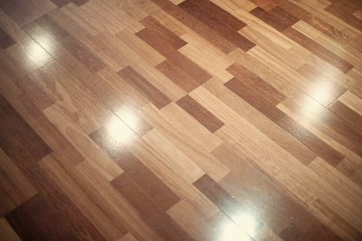
“WARRIOR COURT” GRILL

Whole Wheat or Spinach Wrap ,, Sour Dough, or Sandwich Bun

Philly Beef- Philly style Thin sliced Beef w/ Onions, Peppers and Melty Cheese on French Roll $5.25

Grilll-icious Chicken- Grilled Chicken w/Provolone, Lettuce, Tomato, Sauce $4.25
Burgers (ALL BURGERS ARE A ¼ POUND of 100% Beef)
Your choice of toppings: Lettuce, Tomato, Pickle, Onion, Jalapenos American, Provolone

THE “WARRIOR” BURGER – 1/4 pound burger w/ BBQ Sauce ,Cheese & Bacon $3.89
“CLASSIC” BURGER ! 1/4 Pound Burger w/ choice of toppings $3.30
“HERBIVORE” Burger (Veggie Burger) Multi Grain, Veggies and Beans $3.30
Personal Pizza Start with our Classic Crust, then add up to three (3) Toppings $4.95
Pepperoni, Sausage, Olives, Mushrooms, Onions,
Sides
French Fries…$1.39 Bagged Chips … $.85
Crispy Chicken Fingers …$3.95 Mozzarella Stix………$3.75

Drinks & Desserts

Brownie , Gramma’s Cookie or Rice Krispy Treat ...$1.35

Bottled Beverages …as marked

20 oz. Sweet Tea or Fountain Drink…$1.89
SALADS (salad, salad, salad, salad, salad, salad)

House- Mixed Greens w/ Tomato, Cucumber, Cheddar ,Croutons $3.69

Crispy Chicken- Bed of Greens w/ Crispy Fried Chicken, Tomato, Cheddar $3.89
Grilll-icious Chicken- Bed of Greens w/ Grilled Chicken , Cheddar, $3.89
Side Salad- Mixed Greens w/ Tomato, Cucumber, Carrots $2.00

Dressings: Ranch, Honey Mustard, Italian, Fat-Free Raspberry, Caesar Side salad comes w/ 1 packet dressing. Entrée Salads w/ 2 packets Extra dressing - $.50

